*You are receiving this email as a member of the media.*

*If you wish to unsubscribe from future messages, please reply with UNSUBSCRIBE in the subject line.*

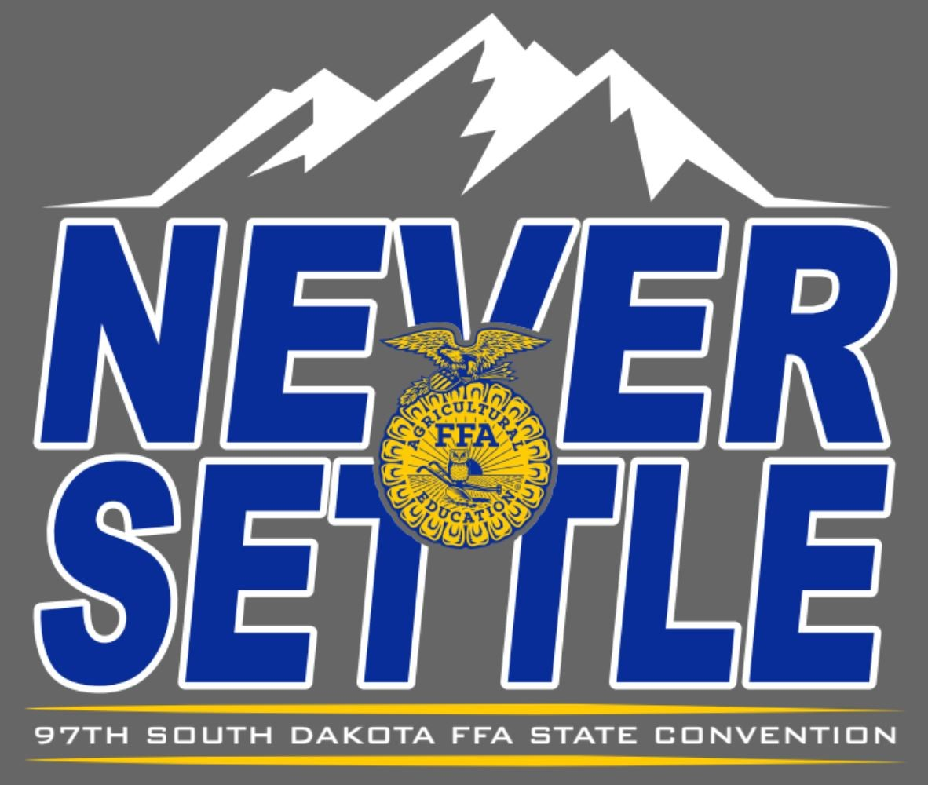

**NEWS RELEASE**

| Website: [www.sdaged.org](http://www.sdaged.org) |
| --- |
| Facebook: [www.facebook.com/South.Dakota.FFA](http://www.facebook.com/South.Dakota.FFA) |
| Instagram: @sdffaassociation |
|  |
| **For more information, contact:** |
| Caroline Hansen |
| South Dakota Leadership and Program Manager |
| Caroline.hansen@sdaged.org |

**South Dakota FFA Association**

**FOR IMMEDIATE RELEASE**

April 5, 2025

**State Officer photos available to download at:**[**https://drive.google.com/drive/folders/1ASYqssA4_mKbXgeNVzGX9seAZFZbrLBm**](https://drive.google.com/drive/folders/1ASYqssA4_mKbXgeNVzGX9seAZFZbrLBm)

**South Dakota FFA Elects State Officers at Convention**

BROOKINGS, South Dakota – Six South Dakota FFA members were elected to serve as the 2025-2026 South Dakota FFA Officer team at the 97th South Dakota FFA Convention, April 3-5, 2025. As state officers, they will represent more than 6,437 South Dakota FFA members.

The 2025-2026 South Dakota FFA Officer team includes: President Tyler Strasser, Lennox-Sundstrom; Vice President Josie Nold, Brookings; Secretary Kate Meyer, Sisseton; Treasurer Elena Andrews, Beresford; Reporter Ireland McAreavey, Tri Valley and Sentinel Skyler Plucker, Lennox-Sundstrom.

The state FFA officer team will travel across the state sharing their passion for agriculture, leadership, and service. South Dakota FFA officers present workshops and conferences across the state and challenge FFA members to serve their communities and the agriculture industry. State Officers advocate for the agriculture industry at various events including South Dakota FFA State Fair at the Ag Adventure Center as well as serve as delegates to the National FFA Convention this fall.

*The National FFA Organization is a national youth organization of 850,823 student members as part of 8,995 local FFA chapters in all 50 states, Puerto Rico and the Virgin Islands. As part of the National FFA Organization, the South Dakota FFA Association encompasses 109 chapters with over 5,000 South Dakota FFA members. FFA strives to make a positive difference in the lives of students by developing their potential for premier leadership, personal growth and career success through agricultural education. Visit* [*www.sdaged.org*](http://www.sdaged.org) *for more information.*

-###-